SCHOOL DISTRICT 35 (LANGLEY)
Action Plan For Learning
Alex Hope Elementary
2016-2017

Kelly Paddock: Principal
Tim Bonnar: Vice Principal

SCHOOL CONTEXT:
Alex Hope Elementary is a dual track Late French Immersion school located in Walnut Grove, in the Township of Langley, B.C. The school serves a population of 569 students from Kindergarten to Grade 7.
Alex Hope has a number of International Students enrolled and a healthy ELL population, making the school a multi-cultural learning environment. The school has strong community support and a dedicated Parent Advisory Council.

DEMOGRAPHICS (2015-16 Statistics)
Aboriginal Students: 12
English Language Learners: 74
International Students: 19; 37 anticipated for 2016-17
Special Education Students: 36
Teachers: 33
SEAs: 11 FTE
Other Staff: 8
REFLECTIONS:
WHAT THE DATA TELLS US
The Middle Years Development Index (MDI):
Alex Hope Elementary has a reputation as a high performing school. The MDI (Fall, 2015) indicates that, overall, our students are well nourished, healthy, have good relationships with significant adults and peers and have a comparatively high well-being index. The students at Alex Hope are extremely active and involved in many after school activities.
Foundational Skills Assessments (FSAs):
When examining the data from the 2016 FSA for Grade 4 and 7, it is apparent that our students scored quite well overall. We know that this standing can be attributed to the socio-economic standing in the Walnut Grove region, but we believe that the strength and professionalism of the teachers and the stability of the school staff has a large effect on student success.
Grade 4 Results: 2016 Compared to 2015:
Reading  FSA | Gr. 4 Reading  2016 | 2016 | 2015
EE | 27 | 38% | 29%
FME | 28 | 39% | 46%
MME | 12 | 17% | 25%
NYM | 4 | 6% | 0%

Writing  FSA | Gr. 4 Writing  2016 | 2016 | 2015
EE | 4 | 5% | 8%
FME | 33 | 45% | 52%
MME | 33 | 45% | 29%
NYM | 3 | 4% | 12%
The Grade 4 Reading results demonstrate a drop (6% Not Yet Meeting) from the 2015 group of students compared to the 2016 group. Despite this, 77% of our Grade 4 students in 2016 were Fully Meeting or Exceeding Expectations compared to 75% in 2015. Our current (2016) group of Grade 4 students will be discussed in more detail under District Reading Assessments.

The Grade 4 Writing FSA scores in 2016 compared to last year’s Grade 4 students demonstrate significantly less students Not Yet Meeting Expectations. There is, however, a higher percentage of students that are Minimally Meeting Expectations.
Numeracy  FSA | Gr. 4 Numeracy  2016 | 2016 | 2015
EE | 19 | 28% | 33%
FME | 25 | 36% | 31%
MME | 18 | 26% | 24%
NYM | 7 | 10% | 12%

The Grade 4 Numeracy FSA scores in 2016 are relatively stable with less students Not Yet Meeting Expectations. It is apparent that there are many very good Math students at Alex Hope.
Grade 7 Results: 2016 Compared to 2015:
Reading  FSA | Gr. 7 Reading  2016 | 2016 | 2015
EE | 22 | 31% | 34%
FME | 28 | 40% | 43%
MME | 19 | 27% | 19%
NYM | 1 | 1% | 4%
The comparative results demonstrate a slight decline in reading scores for the Grade 7 students in 2016 compared to 2015. There are, however, less students Not Yet Meeting Expectations in 2016.
Writing  FSA | Gr. 7 Writing  2016 | 2016 | 2015
EE | 13 | 19% | 4%
FME | 23 | 33% | 51%
MME | 30 | 43% | 44%
NYM | 4 | 6% | 1%
The FSA results for Writing in Grade 7 demonstrate many more students Exceeding Expectations in 2016. The percentage of students Minimally Meeting Expectations has remained stable with an increase in students Not Yet Meeting.

Numeracy  FSA | Gr. 7 Numeracy  2016 | 2016 | 2015
EE | 28 | 38% | 30%
FME | 22 | 30% | 35%
MME | 17 | 23% | 23%
NYM | 6 | 8% | 9%
As reflected in the Grade 4 Numeracy FSA scores, it appears that Alex Hope has strong Math students overall. While a significant percentage of students are Minimally Meeting Expectations, few are Not Yet Meeting and many are Fully Meeting or Exceeding Expectations. Numeracy does not appear to be an area of need at Alex Hope at this time.

District Numeracy 3 & 6 and the District Writing 5 Assessments:
The District Numeracy Assessment (DNA) for Grade 3 demonstrates very good results in comparison to the 2013 data (see Tables below). This may be attributable to the work that the primary teachers undertook as their inquiry in 2014-15. Many teachers in the primary department attended in-service in Mastering the Facts, Guided Math and in using Math games to support learning. At the Grade 6 level, the results demonstrate a significant drop in the number of students Exceeding or Fully Meeting Expectations and this was good information for our Gr. 7 teachers in 2015-16. The District Writing Assessment (DWA) at Grade 5 also indicates a drop in relative ranking over 2013. While many factors play into these assessment results, it is cause for reflection among our staff. Overall, however, the majority of students at Alex Hope are Fully Meeting or Exceeding Expectations in both Numeracy and Writing according to the data. Very few students are in the Not Yet Meeting category.

DNA | Gr. 3 | 2016 | 2015 | 2013
EE | 7 | 12% | 21% | 7%
FME | 43 | 72% | 62% | 70%
MME | 10 | 17% | 6% | 22%
NYM | 0 | 0% | 1% | 1%

DWA | Gr. 5 | 2016 | 2015 | 2013
EE | 7 | 10% | 6% | 8%
FME | 41 | 61% | 66% | 64%
MME | 18 | 27% | 26% | 27%
NYM | 1 | 1% | 1% | 1%

You will notice that the results from 2015 and 2016 DNA6 are identical. There must be an error made at the District level.
DNA | Gr. 6 | 2016 | 2015 | 2013
EE | 17 | 20% | 20% | 25%
FME | 32 | 39% | 39% | 49%
MME | 28 | 34% | 34% | 21%
NYM | 6 | 7% | 7% | 6%

District Reading Assessments (Gr. 1-3):
Of particular interest, when comparing the 2013 and 2015 Grade 1-3 Reading Assessments, Alex Hope reflects the trend in the District with a drop in reading achievement. At the Grade 1 level in June, 2013:
73% Exceeded Expectations
27% Fully Met Expectations
0% Minimally Met or were Not Yet Meeting Expectations
See the table below to compare the Grade 1, 2013 results to the same class, in Grade 3, in 2015 and FSA scores in Grade 4, 2016 in Reading:
Reading  Assessments | 2013 Gr. 1 | 2015 Gr. 3 | 2016 Gr. 4  FSA RE
EE | 73% | 40% | 38%
FME | 27% | 17% | 39%
MME | 0% | 23% | 17%
NYM | 0% | 20% | 6%

When drilling down, it was discovered that in 2013, in Grade 1 eighteen students were reading at a level 16, the expected level by the end of Grade 1. Nearly the same number of students (15), were Not Yet Meeting Expectations in Grade 3. These are students that are discussed at our School Based Team Meetings and who are struggling in Grade 4 in 2015-16. Many of these students receive Learning Assistance Support. Of concern, however, is that these same students met expectation in Grade One at Level 16 and some are now having difficulty with reading at grade level. When comparing the Grade One and Three Reading Assessments to the 2016 FSA Reading Scores, we can see that the students demonstrated improvement in Reading. Staff has questioned why and how the drop by Grade 3 occurred. Fortunately, scores rebounded to an upward trend with these same students according to the 2016 FSA in Reading. There are, however, 6% of these current Grade 4 students who are Not Yet Meeting Expectations according to the FSA4.
In April 2016, one Grade 4 class was chosen to participate in the Progress in International Reading Literacy Study (PIRLS). We have not received the results as of this writing.

Action Plan For Learning 2015-16 In Review:
2015-16 was the third year of our Action Plan For Learning in which teachers were given the opportunity to inquire into an area that they wanted to pursue with their students. This provided teachers with the opportunity for personal and small group choice in deciding where they wanted to expend their energies to improve their practice and increase student learning versus having a single school goal. The inquiry became the focus for both the Action Plan for Learning and the Collaboration Sessions.

Alex Hope Elementary’s Action Plan For Learning
Question for Inquiry 2015-16:
What effect will the implementation of (a strategy or program) be on increasing student achievement in that area?
Example: What effect will the implementation of Guided Math have on increasing student conceptual development of Math in my primary classroom?

Teachers worked in small groups on similar questions for inquiry. The range of questions was broad with all teachers involved including the specialist teachers such as the Music teacher. Below are some examples of the questions for inquiry in 2015-16:
• How can we infuse and integrate Aboriginal content throughout the curriculum to nurture and enhance the learning of all students? (Kindergarten)
• How would implementing some SEL components into the classroom affect student’s ability to recognize and regulate their emotions so they are ready for learning? (LA/Resource Teachers)
• How will using an “I Wonder” book lead to more interest and deeper research with our “Animal Reports” in Science? (Grade Two)
• How can we encourage and increase critical thinking skills in students’ projects and daily work? (Grade Four and Five)
• How do I communicate and give feedback effectively to increase student understanding and achievement? (Fine Arts)
• How will implementing the Redesigned BC Curriculum increase the reading achievement of struggling readers in Grade One? (Grade One)
• How can I best increase student’s interest and reading comprehension in non-fiction with topics within grade curriculum? (Grade Four)
• How can we incorporate student inquiry to promote comprehension of the French Language? (Grade 6 Late French Immersion)
Teachers reported out on their work during the last Collaboration afternoon in May, 2016. The level of discussion, reflection and insight into their teaching during Collaboration Sessions throughout 2015-16 was impressive. They reported increased student engagement and enhanced concept development in Science, deeper understandings of text and students having more awareness of their emotional state which meant they were ready for learning. There is evidence that students are asking good questions and becoming more involved in inquiry. The teachers were observed to be very engaged in examining and improving their own practise in order to increase student achievement. And perhaps even more significant was the increased collaborative culture of the school as a result of the inquiry process and Collaboration Sessions. Their work was authentic, personally meaningful and relevant to their own teaching practise and they collectively appreciated and supported each others’ successes and frustrations.

Reaching the Vulnerable Students in the School:Work in 2015-16 and Plans for 2016-17
A number of initiatives to support our most vulnerable students continued or were initiated in 2015-16 and will continue into 2016-2017. Our parntership with Big Brothers and Sisters of Langley in the Teen Mentorship In School Program continued with some of our students to increase self-esteem and connectedness with a mentor. The Go Girl! and Game On! after school programs were implemented this school year with great success at the Grade 5 level for some vulnerable girls and boys.
The survey results from the MDI, indicated that a significant amount of students in Grade 7 did not feel a strong connection with an adult at the school. This is an area that staff will address in 2016-17 as Grade 7 students are often the most behaviourally challenging students in our school. It is hoped that by increasing connectedness, we will see a decrease in disengaged and disruptive students.
Our Reading Recovery program (.2 FTE) continued with our very talented teacher and she was able to serve four students this year with good results.
A team of four teachers, including one administrator, attended the Faye Brownlie series and shared and implemented many activities with their students to engage and increase the time students had their eyes on print. Examples are the “Reading Like a Scientist” and “Beach Reading” in a K/1 class.
As a result of our concern about declining scores in Reading at the Primary Level, a Literacy Committee was struck with representation from Administration, Primary and Intermediate Teachers, LA/Resource Teachers and our Library Technician. Initial discussion resulted in some initiatives for this school year and some longer term planning for 2016-17.
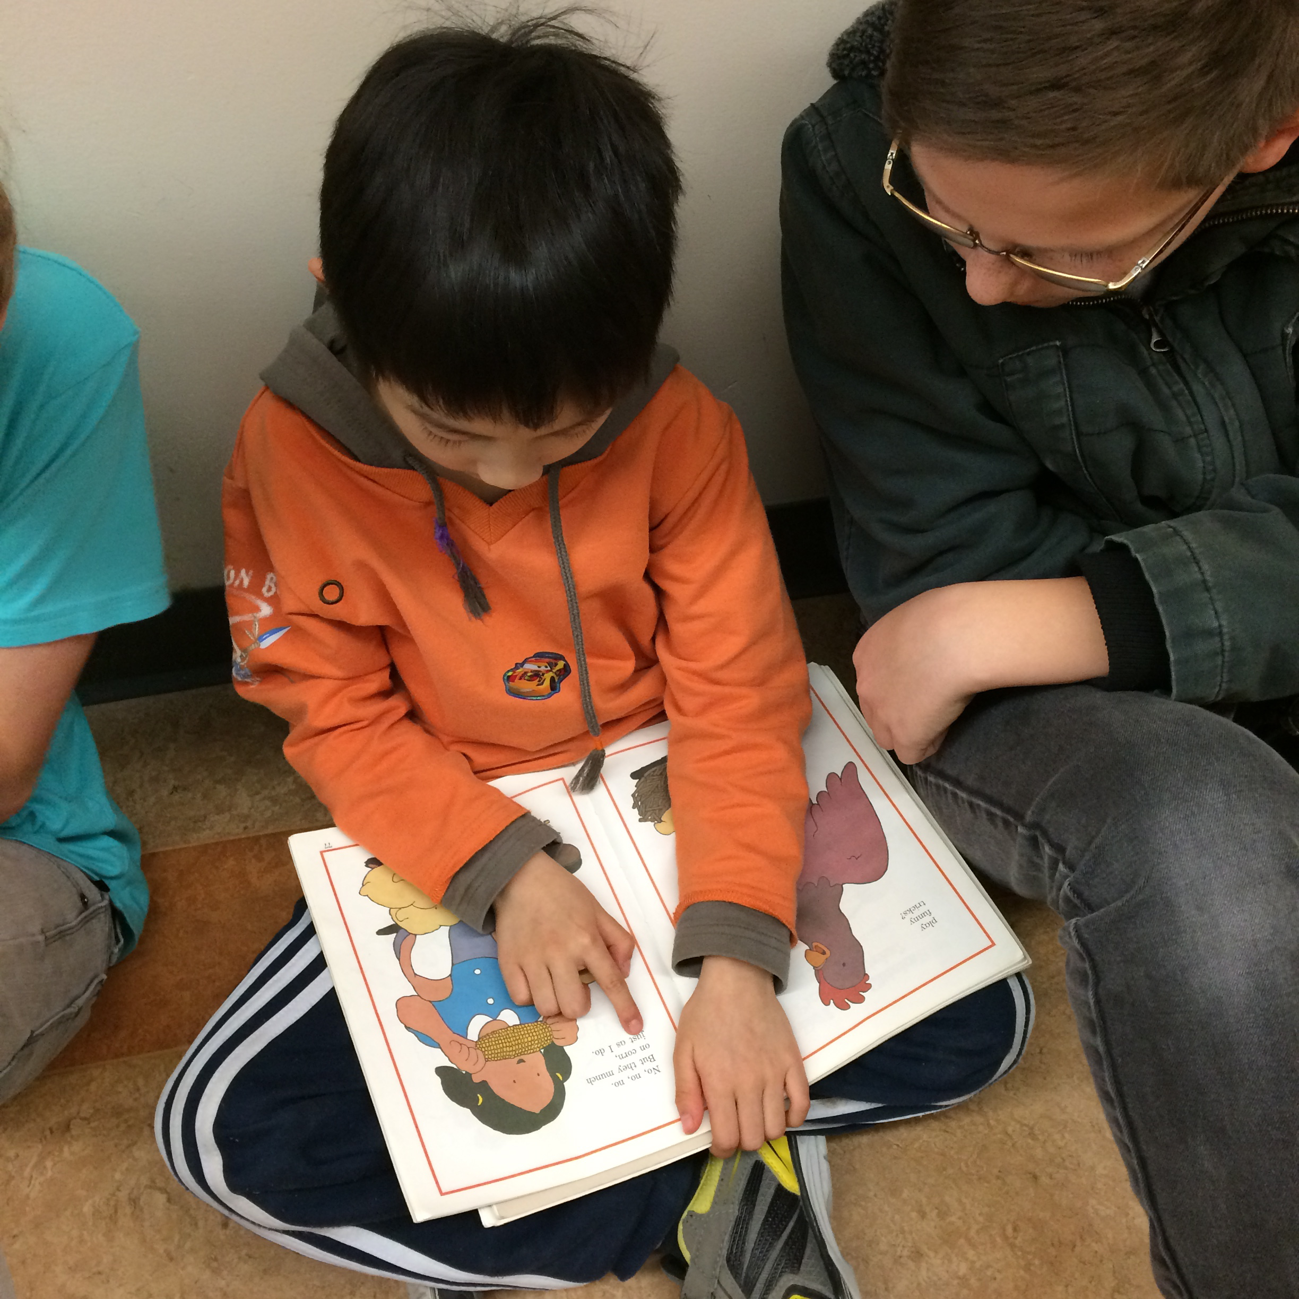
Among the initiatives for 2015-16, was the reinstatement of the Peer Reading Club for students in Grade One to Three. In this daily reading program, students in Grade Five are paired with younger students and trained to support reading fluency and comprehension.
Our LA/Resource Teacher implemented a “Read to Me” program with community volunteers reading with ELL and struggling readers twice weekly.
In addition, the Primary Resource Teacher re-shaped her schedule to concentrate on working with struggling readers in Grade One in the Early Literacy Intervention Program. From this, three students improved their reading scores by one year to one and half years and the others demonstrated good growth.
The Alex Hope Literacy Committee has met twice this spring and began some initiatives including:
• A Family Literacy Night in January, 2017 with theme stations
• Monthly themes for reading Read a Mystery in October, Non-Fiction in November, Poetry in February etc.
• A book mark design contest with a diagram from a favourite book on one side and reading strategies on the other.
• Promotion of audio books
• Bookmaking projects for Buddy classes
• Video clips and movie trailers to promote books
• Displays in the library to showcase books and genres: “ If you liked Hunger Games, then you will like _____”
• PJ and flashlight reading days once per term
• Promotion of the Langley Book of the Year and Picture Book of the Year
In addition, there is a new monthly section in the Alex Hope News called “Literacy Corner” where suggestions for parents are given on how to promote literacy with their children in the home.

ACTION PLAN FOR LEARNING 2016-17:
Considering the concern about the apparent drop in reading scores that appear to be following the District trend, the staff of Alex Hope have agreed to focus their inquiry and professional growth on inquiry into strategies for increasing Literacy skills in our students.
There will be some specialist teachers (example: our Music Teacher) who will focus on inquiry in her specialty area, but the majority of teachers will focus on Literacy with many incorporating the implementation of the Redesigned Curriculum.

Alex Hope Elementary’s Action Plan For Learning
Question for Inquiry 2016-17:
What effect will the implementation of (a strategy or program) be on increasing student achievement in Literacy?
Example: What effect will the implementation of the Daily Five have on increasing student achievement in Reading in my primary classroom?
Target: Increase the number of students who are Fully Meeting or Exceeding Expectations in our current primary classes from our 2015 and 2016 Reading assessments in the 2017 Reading Assessments and the FSA4. A target for the end of Grade One would be at least Level 17 or 18. We hope to have 1% or less of students Not Yet Meeting expectations in Grade 1-7 in Reading according to District assessments and the FSA4 and 7.

Actions:
• The Literacy Committee will meet regularly to discuss and organize school wide Literacy initiatives (see list of plans for 2016-17 listed above)
• A Family Literacy Night will be scheduled for January, 2017 with stations for families to enjoy reading and to provide parents with strategies for supporting the literacy development of their children
• School teams will be encouraged to attend District Literacy in-service initiatives such as Faye Brownlie’s Ignite series
• Reading Recovery and Early Literacy Intervention will continue at the Primary level
• Reading Club will begin in the early Fall
• The Read To Me program will continue and be enhanced
• Two teachers (our ELL and a LA/Resource Teacher) will attend the SIOP training in June, 2016 to support our growing ELL students in the classroom
• Collaboration Afternoons will be focussed on Literacy
• Books with Aboriginal themes and dual language books will be purchased for classrooms and the library as our budget enables us
• PAC will be given updates on our Action Plan For Learning and for teacher inquiry
• A “Literacy Corner” in the monthly newsletter will focus on strategies for parents to encourage a love of reading
• Discussion and decisions around a more standardized reading assessment at the Intermediate level will be investigated to help support and provide data on reading ability

Evidence of Success:
Success will be measured qualititatively and quantitatively through the Grade One to Three Reading Assessments, the DWA5 and the FSAs and through anectdotal narratives and student portfolios. Reports from our LA/Resource and Reading Recovery Teacher will be used as evidence of progress in developing and improving skills in reading and writing.

